PROJECT DOCUMENT

Project title:
AI StudyBuddy API

1. Introduction:
Project title: AI StudyBuddy API
Team ID: SWTID-2026-1935
Team size: 4
Team leader: [HEMALATHA.V] [hemalathavinayagam2006@gmail.com]

Team members:
JANANI.R [rjananiravi143@gmail. com]
KAVIYA.P [KAVIYAPALANI719@GMAIL.COM]
JANANI.S [K55182981@gmail.com]

2. Project Overview

DESCRIPTION:
AI StudyBuddy is an AI-powered learning assistance platform developed to simplify the study process for students by leveraging modern web technologies and Generative AI. The application provides an intelligent backend system that enables students to upload study materials, generate concise summaries, create flashcards, produce quizzes, and receive personalized study plans through AI-generated responses.
The backend is developed using Node.js and Express.js, following a RESTful API architecture that ensures scalability, maintainability, and secure communication between the frontend and backend services. MongoDB serves as the primary NoSQL database, while Mongoose ODM provides schema validation, data modeling, and efficient database interactions.
To secure user information and protected resources, the application implements JWT (JSON Web Token) based authentication along with Role-Based Access Control (RBAC). Users are authenticated before accessing AI-powered features, ensuring that only authorized users can utilize premium learning services. Passwords are securely encrypted using bcryptjs, preventing unauthorized access to user credentials.
A key highlight of AI StudyBuddy is its integration with the Google Gemini AI API, which enables the application to perform advanced natural language processing tasks. Instead of relying on predefined templates, the backend dynamically communicates with the Gemini model to generate high-quality educational content based on the study material provided by the user.

FEATURES:
Users can create a new account by providing their name, email, and password. Users can log in using their registered email and password. After login, the system generates a JSON Web Token (JWT) to securely verify the user.
Users can upload or enter study material and use AI-powered features to generate summaries, flashcards, quizzes, and personalized study plans. Users can view and manage the learning resources they have generated.
Certain API routes can only be accessed by authenticated users, and role-based access control restricts premium/admin features to authorized roles. The system manages errors and provides proper responses if something goes wrong.

3. Scenario-Based Case Study

Background
Rahul is a second-year engineering student preparing for multiple semester examinations while simultaneously learning new technical skills for internships and placement opportunities. His study materials are scattered across lecture notes, PDFs, textbooks, online articles, and handwritten notes, making it difficult to organize and revise effectively. Due to the large volume of content and limited preparation time, Rahul often struggles to identify important concepts, create revision notes, and evaluate his understanding before examinations.
Traditional study methods require significant manual effort to summarize lengthy materials, prepare practice questions, and create revision schedules. This process is repetitive, time-consuming, and often results in inconsistent learning outcomes.

Problem
Rahul encounters several challenges during his preparation:
- Difficulty understanding lengthy study materials within limited time.
- Manual preparation of notes consumes a significant amount of study time.
- Creating flashcards and revision questions is repetitive and labor-intensive.
- Lack of personalized study plans based on available time and examination schedules.
- No centralized platform to securely store AI-generated learning resources.
- Difficulty assessing knowledge through self-generated quizzes.
- Switching between multiple applications for note-taking, quizzes, and scheduling reduces productivity.

Solution
The AI StudyBuddy backend provides a centralized, AI-powered learning platform that automates several academic tasks through intelligent content generation. The system enables authenticated users to upload or enter study materials and leverage the Google Gemini AI API to generate educational resources automatically.
The backend processes incoming requests through secure RESTful APIs and performs the following operations:
- Authenticates users using JWT-based security.
- Stores user information and study resources in MongoDB.
- Sends study content to the Google Gemini AI model through dedicated AI service modules.
- Generates concise summaries for faster revision.
- Creates flashcards for active recall learning.
- Produces multiple-choice quizzes for self-assessment.
- Generates personalized study plans based on user preferences and examination timelines.
- Stores generated learning resources for future retrieval and continuous learning.
By separating authentication, business logic, database operations, and AI processing into modular components, the backend ensures maintainability, scalability, and efficient request handling.

4. Usage

Student Usage
Students register and log in to the application before accessing AI-powered learning features. After authentication, they can upload study material or provide textual content and choose the desired AI functionality, such as generating summaries, quizzes, flashcards, or personalized study plans. The generated content can be reviewed immediately and stored for future reference.

Administrator Usage
Administrators manage registered users, monitor application activity, oversee system usage, and maintain platform integrity. Administrative privileges include managing user accounts, monitoring AI service utilization, reviewing system logs, and ensuring smooth backend operations.

5. Outcome
By integrating artificial intelligence with a secure backend architecture, AI StudyBuddy significantly improves the learning experience for students. Manual preparation time is reduced through automated content generation, allowing students to focus more on understanding concepts rather than organizing study materials.
The implementation of JWT authentication, MongoDB data management, and Google Gemini AI integration ensures that educational resources are generated securely, efficiently, and consistently. The modular backend architecture further supports future enhancements, enabling additional AI-powered learning capabilities to be integrated with minimal architectural changes.
As a result, AI StudyBuddy serves as a scalable and intelligent educational platform that enhances productivity, promotes effective revision, and supports personalized learning for students preparing for academic examinations and competitive assessments.

6. ARCHITECTURE
AI StudyBuddy follows a three-layer architecture, with an added AI service layer.
1. Backend:
Powered by Node.js and Express.js, managing server-side logic, API endpoints, and data exchange between the frontend and backend services.
2. Database:
MongoDB (via Mongoose) is used to store user data, uploaded study materials, and AI-generated learning resources.
3. AI Service Layer:
Dedicated AI service modules communicate with the Google Gemini AI API to generate summaries, flashcards, quizzes, and study plans from user-provided study material.

7. Setup Instructions

Software Requirements
- Operating System: Windows 10/11, macOS, or Linux (cross-platform).
- Node.js (v16 or above): runtime for server logic and routing.
- npm (v8 or above): package manager for dependencies.
- Express.js: routing framework for the RESTful API.
- MongoDB: NoSQL database for users, resources, and analytics.
- Mongoose: ODM for schema validation and data modeling.
- Postman: API verification and schema/response testing.
- Visual Studio Code (or similar IDE).

Hardware Requirements
- Processor: Intel Core i5 (8th Gen or above) / AMD Ryzen 5 or equivalent.
- RAM: 8 GB minimum (16 GB recommended for concurrent MongoDB, processing, and execution nodes).
- Storage: 1 GB of available disk space.

Steps
- Install Node.js and MongoDB
- Clone the project repository
- Install dependencies using npm install
- Start the server using npm start

8. Folder Structure
Main folders in the project:
- models → Database schemas
- routes → API routes
- controllers → Business logic
- middleware → Authentication and security
- server.js → Main backend file

9. API Endpoints
User API
- Register user
- Login user
- Get logged-in user profile
Study Material API
- Upload / add study material
- Get study materials
- Delete study material
AI Learning API (Gemini-powered)
- Generate summary
- Generate flashcards
- Generate quiz
- Generate personalized study plan
Admin API
- Get all users
- Monitor AI service usage / system logs

10. Authentication
The system uses JWT (JSON Web Token) based authentication along with Role-Based Access Control (RBAC).
After login, the server generates a token, and passwords are encrypted using bcryptjs before being stored.
The token is used to access protected routes, and RBAC restricts admin-only routes to authorized roles.

11. Testing
Testing ensures the system works correctly.
Tools used:
- Postman – Test API endpoints
- Thunder Client – Test API endpoints
- Chrome Developer Tools – Debug frontend

12. Future Enhancements
- Mobile application support
- Reminder notifications for study sessions and revision schedules
- Study progress tracking and analytics dashboard
- Peer study-partner matching
- Voice-based Q&A with the AI assistant

13. PROJECT EXECUTION
Project Execution Steps
- Start MongoDB
- Run server
- Test APIs in Thunder Client / Postman
- Register user
- Login and get JWT
- Perform CRUD operations

14. Project Output Screenshots

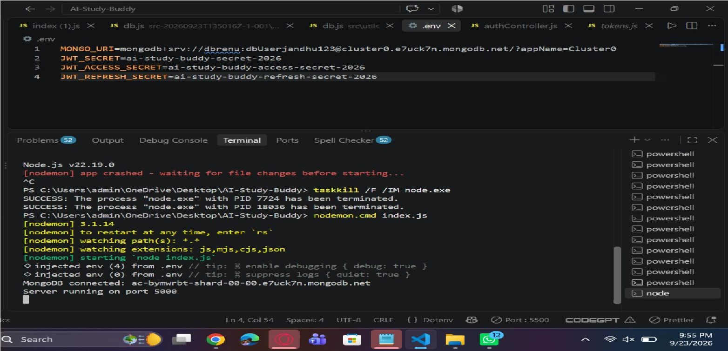

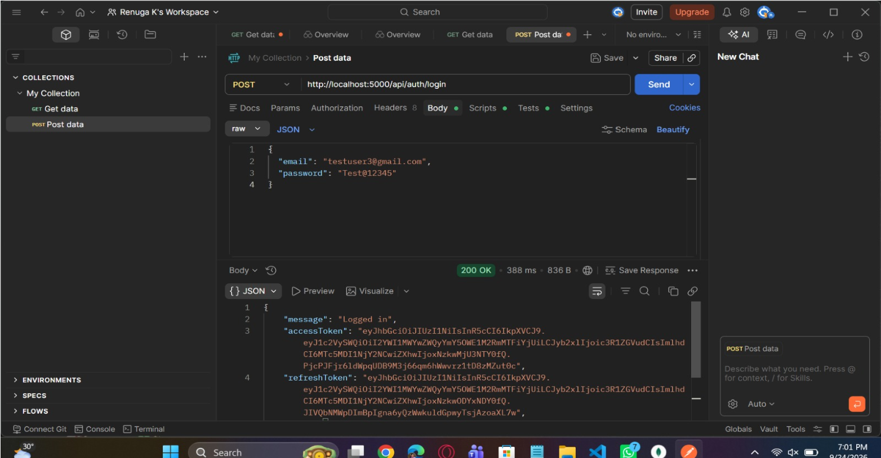

15. Known Issues
No Frontend Integration
- The current system mainly focuses on backend API development. A full frontend interface is not integrated yet.
Token Expiration Handling
- When the JWT token expires, users need to log in again. Automatic token refresh is not implemented.
Limited Validation
- Input validation for user data and study goals is basic and may need improvement for production use.
Error Handling Improvements
- Some API responses may not provide detailed error messages for debugging.
Scalability Issues
- The backend is designed for small-scale use and may require optimization for large numbers of users.
No Rate Limiting
- The system does not currently restrict repeated API requests, which may affect security.

